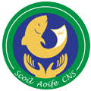

**Scoil Aoife**

**Winter Newsletter 2019**

**Important Reminders**

* School will close early at 12:00pm on Friday 20th December. School will reopen at 9am on Monday 6th January.
* Please inform the office of any changes to contact details e.g. new address or phone number.
* School will be closed on Friday 10th January for Staff Training.

Well it’s hard to believe that another year is over and a new one about to begin! We have had a very busy term and have lots planned for next year. To those of you who celebrate Christmas, we wish you a peaceful and happy holiday. We look forward to seeing you at our winter performances this week and I know the children are looking forward to seeing you too. I want to thank our parents for all their support throughout this term. Children whose parents get involved with school, perform better. A special thank you to the Parents Association who helped in so many ways. Remember they are always keen for new members and ideas. Thank you to all our teachers and SNA staff, Tina and Vinnie who all help to make Scoil Aoife a better place. Good health to all for 2020. Ms Mc Auley

**Parents Association Raffle**

The Parents Association are running a raffle during the last week of school. They will be selling tickets at 9 am, 1.40pm and 2.40pm each day from Monday 16th December to Wednesday 18th December. The raffle will take place on Thursday 19th December. Thank you to all involved in organising the raffle.



Remember to keep updated with our school news, calendar and photographs by visiting our website **www.scoilaoifecns.ie**.

**Parent Teacher Meetings**

Parent Teacher Meetings took place in November. Thank you to all who attended. These meetings are an excellent opportunity to discuss children’s progress so far this year. If you missed your child’s appointment, please do not hesitate to arrange a meeting with your child’s teacher.



**Maths Week**

Maths Week took place in November and it was a great success. There was lots of problem solving, maths trails and maths games going on in every class. Some classes used the Izak9 box, which had lots of online tasks and problems for children to solve in groups. They worked so well in their teams. The classes also mixed up with each other to play snakes and ladders.

**Winter Performances**

|  |
| --- |
|  |

Each class has been rehearsing for their Winter Performance, and the audience is in for a real treat this year! There will be songs, poems, dancing, music and acting and all the staff and children have been working very hard in anticipation of the concerts.

The Magic Garden will perform on Tuesday 17th December at 10.30am.

Junior Infants, 1st Class and 4th Class will be performing on Tuesday at 12.30pm.

Senior Infants, 2nd Class and 3rd Class will perform on Wednesday at 12.30pm.

Tickets are €2 and can be purchased from the class teacher.



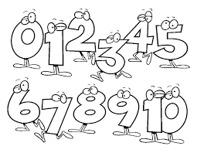

**3rd class visit to Clonliffe College**

On the 13th of November we went on our school trip. It took 1 hour to get to Clonliffe College. When we were getting off the bus there was somebody from Trócaire. He showed us around the college. Then we played a board game.

Then we learned about refugees. The 1st stage was to pack up your things and we only got to pick six items. The 2nd stage was to take cover. We had to use bamboo sticks and tape. The 3rd stage was to get on the plane. We had to use the money from stage one.

After the day was done, we went back to school.

By Ayo, 3rd class

**School Council**

It has been another busy half term for the School Council representing Scoil Aoife. They have been working hard towards the Green Flag and have been conducting spot checks on the classrooms. Each month they are selecting a Green Class of the month. Congratulations to Room 5 who were the first winners. Room 12 are this month’s Green Class of the month. Well done everyone!



**Per Cent for Art Scheme**

Our school has been fortunate to take part in the Per Cent for Art Scheme. An artist, John O’Connor, was commissioned to produce a piece of art for the school. He also worked with some of the children, producing pictures that will be incorporated into the sculpture. His sculpture has recently been placed in front of the school and is quite spectacular. It is currently close to completion, and we all look forward to seeing it and enjoying it for years to come.



**After School Activities**

There have been various activities going on after school this half term. Got2Dance with Aoife, Tennis with David and Lego Club with Karen. Mr McCarthy has also been running Boys’ Club and the boys are looking forward to their showcase of work. Lego club will continue in the new year along with other After School activities.

**Coding in 2nd class**

This year in class we have been learning to code with Scratch when we are finished our work early.

I have used backgrounds, sprites and sounds.

I made games like Dinosaur vs Panther, Polar and Soccer.

The game I am most proud of is Soccer.

My favourite thing about coding is coding games.

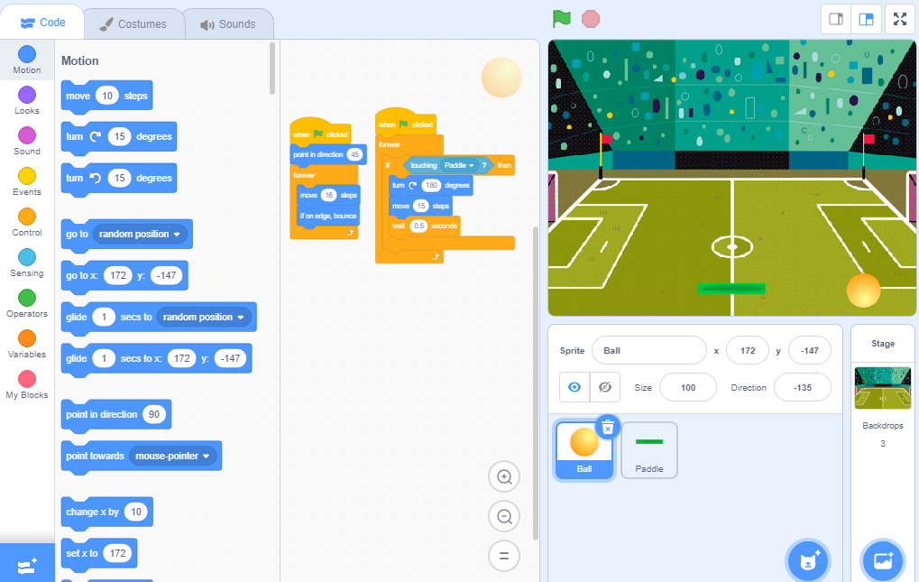By Aidan, Room 16

This is my game 'Soccer'.